Functional Specification

General

Table of Contents

1 PERMISSION CONTROL 2

2 GENERAL PAGE LAYOUT 2

2.1 HEADER 2

2.2 FOOTER 2

3 BURGER MENU & TOP NAVIGATION 2

3.1 Burger Menu 2

3.2 Top Navigation Icons 3

4 SEARCH PANEL 3

5 FILTER PANEL 4

6 WHAT ARE DIFFERENCES BETWEEN OUR WORK AND OMOBONO’S DESIGN 4

# PERMISSION CONTROL

* All pages need to login the site then they can view pages

# GENERAL PAGE LAYOUT

* Each page will be shown as full width of the screen

## HEADER

* There are 3 sizes of header through the site:  
  1. Homepage header is the same height as the screen  
  2. Images search result page, Images detail page, Template detail page, Best Practices detail page header height is 50% of the screen width  
  3. All other pages header height is 30% of the screen width
* Page header includes burger menu, Accenture logo on the top left corner, home and search icon on the top right corner, page title text on the left bottom corder and a scroll promot on the right bottom corner.
* Burger menu functions refer to #3 specification below.
* When click Accenture logo and Home icon, will go back to the homepage
* When click search icon, will show search popup, refer to search page specification
* The scroll promot is only shown when page load initially, when user starts to scroll, it will be disappear

## FOOTER

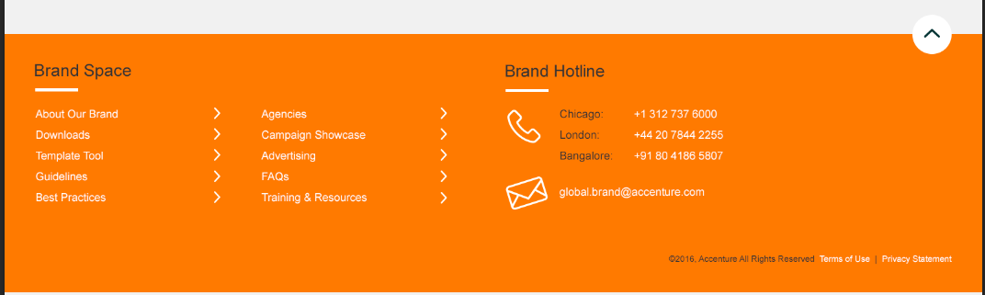

* Footer includes four parts:   
  1. Left navigation which includes first level of menu items, click each link goes to related page  
  2. Brand hotlines and mail box, click mailbox links opens a new email send to Global.Brand  
  3. Go to top button, click it goes to the top of the page  
  4. Copyrights and two links of “Terms of Use” and “Privacy Statement”, click it goes to related pages

# BURGER MENU & TOP NAVIGATION



## Burger Menu Are we engaging the animated features Omobono shared?

* Burger navigation menu will work as a sticky nav that sits at the top of the screen at all times, so when user scroll down the page, the burger menu always on the top of the screen
* By default, the burger menu icon is consist of three bars, the middle bar is shorter than other. When user click it, menu is shown and icon changes to a cross  
   
* Each tier will get a touch darker and include a back button and highlight which one you are in.

|  |  |  |  |
| --- | --- | --- | --- |
| Tier 1 | Tier 2 | Tier 3 | Tier 4 |
|  |  |  |  |

* Menu’s texts are

About Our Brand

Downloads

Images

Templates

Artwork files

Template Tool

Guidelines

o   Introduction

o   Brand Elements

§  Signature and HPD Signature *once on this page, it will then split into two separate pages

§  Business Lockup

§  Greater Than Lockup

§  Strategy Line

§  Business identities

§  Typography

§  Colors

§  Imagery

§  Brand Strategy

o   Guideline Catalog

Best practices

Agencies

Campaign showcase

Advertising

FAQs

Training and Resources

## Top Navigation Icons

* When hover home and search icon, one tooltip is shown under the icon  
  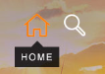 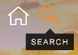
* Click home icon will go back to homepage, click search icon will show the search popup

# SEARCH PANEL

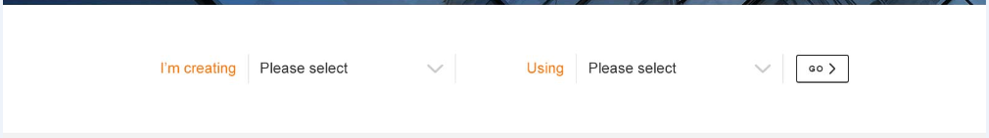

* Search panel always includes two search options which are dropdowns lists
* After choose an option in dropdown, user needs to click “GO” button to start the search, then search result will be shown with pagination
* When hover the “GO” button, its background color changes to orange  
  

# FILTER PANEL

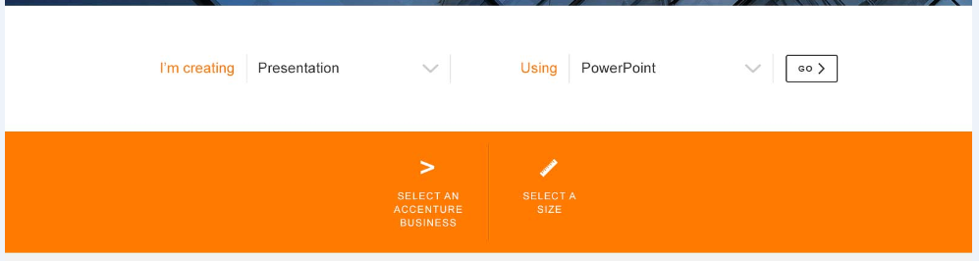

* After user starts a search, filter panel will be shown within an orange bar with different filter options
* When hover one filter option, its icon and text changes from white to black, and related detail filter options list will be shown underneath it with a maximum height, if options list heigh is higher than max height, one scroll bar will be displayed.

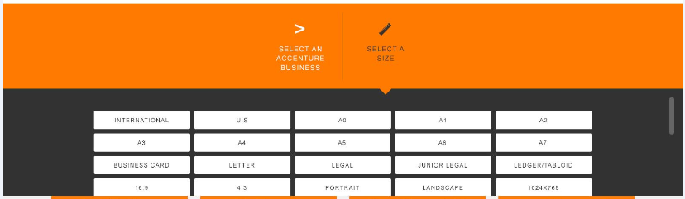

* After choose one option from the options list, that option will be removed from the options list and be included in the “SELECTED FILTERS” panel



* Each item in the “SELECTED FILTERS” panel can be removed by clicking “x” and after removing, it will be re-displayed in the filter options list panel.
* Once a filter option is selected, the search result will be refreshed to displayed the filtered result with pagination

# WHAT ARE DIFFERENCES BETWEEN OUR WORK AND OMOBONO’S DESIGN

* We don’t have the pin, notification and profile icons, but keep the home and search icons on the navigation because these functions are not in scope of the initial launch

|  |  |
| --- | --- |
| Omobono’s design | Our work |
|  |  |

* We don’t have any share/like/pin designed functions because that is out of scope of the initial launch  
   
* The featured campaign showcase is only included in the Campaign Showcase landing page, for other pages, we will not have that section Can we please add back in wherever possible?

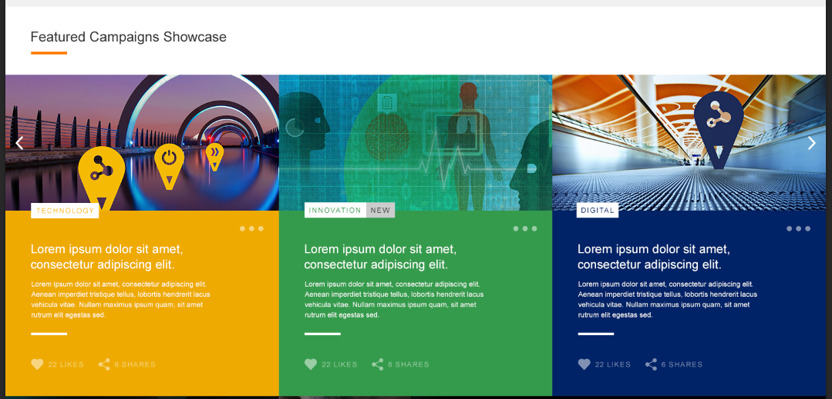

* We don’t have the sign up panel because it is out of the scope of initial launch

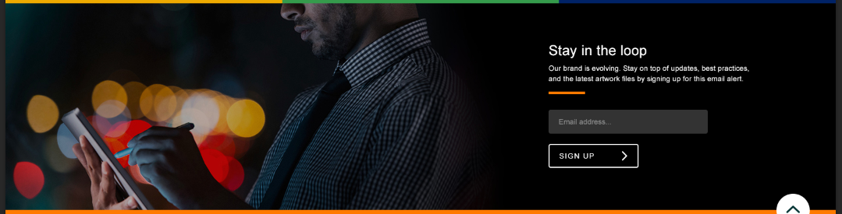

* Search dropdown style in Omobono’s design likes what we can see on Apple devices, but we will only make it as a normal dropdown list style on web pages due to technical limitation

|  |  |
| --- | --- |
| Omobono’s design | Our work |
|  |  |